**LAB # 11 & 12**



**Spring 2022**

**Operating System**

**Submitted By: Maaz Habib, Alishba Orakzai, Nida Asmat Burki**

**Registration No: 20PWCSE1952, 20pwcse1953, 20pwcse1955**

**Class Section:**

**C**

“On my honor, as student of University of Engineering and Technology, I have neither given nor received unauthorized assistance on this academic work.”

Submitted to:

**Engr Mian Ibad**

July 09, 2022

**Department of Computer Systems Engineering**

**University of Engineering and Technology, Peshawar**

**Lab11-Task1:**

**Code:**

#include <iostream>

#include <algorithm>

#include <iomanip>

using namespace std;

struct process {

int pid;

int arrival_time;

int burst_time;

int start_time;

int completion_time;

int turnaround_time;

int waiting_time;

int response_time;

};

bool compareArrival(process p1, process p2)

{

return p1.arrival_time < p2.arrival_time;

}

bool compareID(process p1, process p2)

{

return p1.pid < p2.pid;

}

int main() {

int n;

struct process p[100];

float avg_turnaround_time;

float avg_waiting_time;

float avg_response_time;

float cpu_utilisation;

int total_turnaround_time = 0;

int total_waiting_time = 0;

int total_response_time = 0;

int total_idle_time = 0;

float throughput;

cout << setprecision(2) << fixed;

cout<<"Enter the number of processes: ";

cin>>n;

for(int i = 0; i < n; i++) {

cout<<"Enter arrival time of process "<<i+1<<": ";

cin>>p[i].arrival_time;

cout<<"Enter burst time of process "<<i+1<<": ";

cin>>p[i].burst_time;

p[i].pid = i+1;

cout<<endl;

}

sort(p,p+n,compareArrival);

for(int i = 0; i < n; i++) {

p[i].start_time = (i == 0)?p[i].arrival_time:max(p[i-1].completion_time,p[i].arrival_time);

p[i].completion_time = p[i].start_time + p[i].burst_time;

p[i].turnaround_time = p[i].completion_time - p[i].arrival_time;

p[i].waiting_time = p[i].turnaround_time - p[i].burst_time;

p[i].response_time = p[i].start_time - p[i].arrival_time;

total_turnaround_time += p[i].turnaround_time;

total_waiting_time += p[i].waiting_time;

total_response_time += p[i].response_time;

total_idle_time += (i == 0)?(p[i].arrival_time):(p[i].start_time - p[i-1].completion_time);

}

avg_turnaround_time = (float) total_turnaround_time / n;

avg_waiting_time = (float) total_waiting_time / n;

avg_response_time = (float) total_response_time / n;

cpu_utilisation = ((p[n-1].completion_time - total_idle_time) / (float) p[n-1].completion_time)*100;

throughput = float(n) / (p[n-1].completion_time - p[0].arrival_time);

sort(p,p+n,compareID);

cout<<endl;

cout<<"#P\t"<<"AT\t"<<"BT\t"<<"ST\t"<<"CT\t"<<"TAT\t"<<"WT\t"<<"RT\t"<<"\n"<<endl;

for(int i = 0; i < n; i++) {

cout<<p[i].pid<<"\t"<<p[i].arrival_time<<"\t"<<p[i].burst_time<<"\t"<<p[i].start_time<<"\t"<<p[i].completion_time<<"\t"<<p[i].turnaround_time<<"\t"<<p[i].waiting_time<<"\t"<<p[i].response_time<<"\t"<<"\n"<<endl;

}

cout<<"Average Turnaround Time = "<<avg_turnaround_time<<endl;

cout<<"Average Waiting Time = "<<avg_waiting_time<<endl;

cout<<"Average Response Time = "<<avg_response_time<<endl;

cout<<"CPU Utilization = "<<cpu_utilisation<<"%"<<endl;

cout<<"Throughput = "<<throughput<<" process/unit time"<<endl;

}

**Output:**

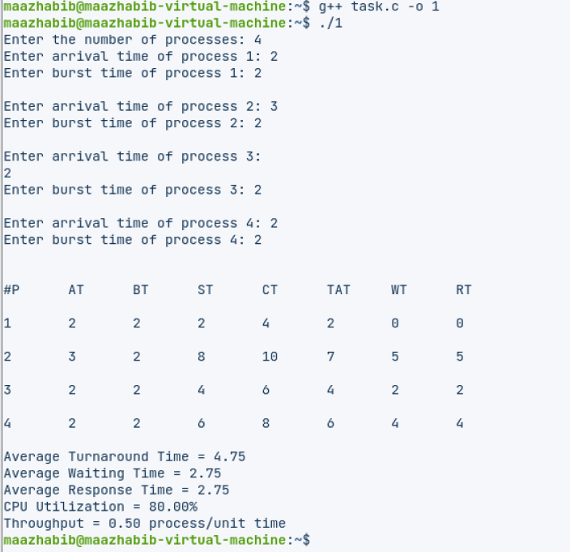

**Lab11-Task2:**

**Code:**

#include <iostream>

#include <algorithm>

#include <iomanip>

#include <string.h>

using namespace std;

struct process {

int pid;

int arrival_time;

int burst_time;

int start_time;

int completion_time;

int turnaround_time;

int waiting_time;

int response_time;

};

int main() {

int n;

struct process p[100];

float avg_turnaround_time;

float avg_waiting_time;

float avg_response_time;

float cpu_utilisation;

int total_turnaround_time = 0;

int total_waiting_time = 0;

int total_response_time = 0;

int total_idle_time = 0;

float throughput;

int is_completed[100];

memset(is_completed,0,sizeof(is_completed));

cout << setprecision(2) << fixed;

cout<<"Enter the number of processes: ";

cin>>n;

for(int i = 0; i < n; i++) {

cout<<"Enter arrival time of process "<<i+1<<": ";

cin>>p[i].arrival_time;

cout<<"Enter burst time of process "<<i+1<<": ";

cin>>p[i].burst_time;

p[i].pid = i+1;

cout<<endl;

}

int current_time = 0;

int completed = 0;

int prev = 0;

while(completed != n) {

int idx = -1;

int mn = 10000000;

for(int i = 0; i < n; i++) {

if(p[i].arrival_time <= current_time && is_completed[i] == 0) {

if(p[i].burst_time < mn) {

mn = p[i].burst_time;

idx = i;

}

if(p[i].burst_time == mn) {

if(p[i].arrival_time < p[idx].arrival_time) {

mn = p[i].burst_time;

idx = i;

}

}

}

}

if(idx != -1) {

p[idx].start_time = current_time;

p[idx].completion_time = p[idx].start_time + p[idx].burst_time;

p[idx].turnaround_time = p[idx].completion_time - p[idx].arrival_time;

p[idx].waiting_time = p[idx].turnaround_time - p[idx].burst_time;

p[idx].response_time = p[idx].start_time - p[idx].arrival_time;

total_turnaround_time += p[idx].turnaround_time;

total_waiting_time += p[idx].waiting_time;

total_response_time += p[idx].response_time;

total_idle_time += p[idx].start_time - prev;

is_completed[idx] = 1;

completed++;

current_time = p[idx].completion_time;

prev = current_time;

}

else {

current_time++;

}

}

int min_arrival_time = 10000000;

int max_completion_time = -1;

for(int i = 0; i < n; i++) {

min_arrival_time = min(min_arrival_time,p[i].arrival_time);

max_completion_time = max(max_completion_time,p[i].completion_time);

}

avg_turnaround_time = (float) total_turnaround_time / n;

avg_waiting_time = (float) total_waiting_time / n;

avg_response_time = (float) total_response_time / n;

cpu_utilisation = ((max_completion_time - total_idle_time) / (float) max_completion_time )*100;

throughput = float(n) / (max_completion_time - min_arrival_time);

cout<<endl<<endl;

cout<<"#P\t"<<"AT\t"<<"BT\t"<<"ST\t"<<"CT\t"<<"TAT\t"<<"WT\t"<<"RT\t"<<"\n"<<endl;

for(int i = 0; i < n; i++) {

cout<<p[i].pid<<"\t"<<p[i].arrival_time<<"\t"<<p[i].burst_time<<"\t"<<p[i].start_time<<"\t"<<p[i].completion_time<<"\t"<<p[i].turnaround_time<<"\t"<<p[i].waiting_time<<"\t"<<p[i].response_time<<"\t"<<"\n"<<endl;

}

cout<<"Average Turnaround Time = "<<avg_turnaround_time<<endl;

cout<<"Average Waiting Time = "<<avg_waiting_time<<endl;

cout<<"Average Response Time = "<<avg_response_time<<endl;

cout<<"CPU Utilization = "<<cpu_utilisation<<"%"<<endl;

cout<<"Throughput = "<<throughput<<" process/unit time"<<endl;

}

/*

AT - Arrival Time of the process

BT - Burst time of the process

ST - Start time of the process

CT - Completion time of the process

TAT - Turnaround time of the process

WT - Waiting time of the process

RT - Response time of the process

Formulas used:

TAT = CT - AT

WT = TAT - BT

RT = ST - AT

*/

**OutPut:**

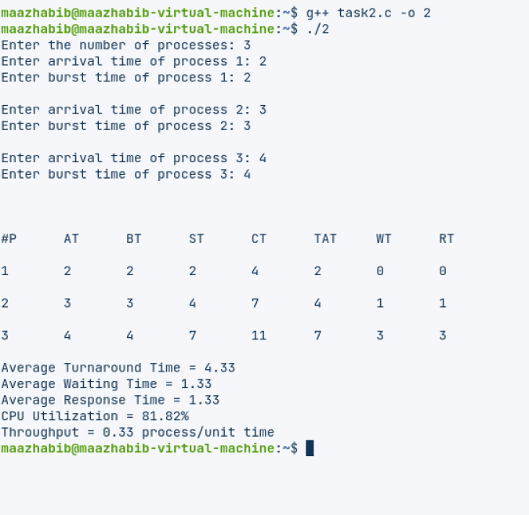

**Lab12-Task1:**

**Code:**

#include<iostream>

#include<queue>

#include<vector>

#include<algorithm>

#define TQ 2

#define NB_PROCESS 7

using namespace std;

class Process{

public:

int process_id;

int arrival_time;

int burst_time;

int remaining_time;

int completion_time = 0;

int turn_around_time = -1;

int waiting_time = -1;

Process(int p_id, int a_time, int b_time){

this->process_id = p_id;

this->arrival_time = a_time;

this->burst_time = b_time;

this->remaining_time = this->burst_time;

}

bool operator!=(Process& p){

if (this->process_id == p.process_id) return false;

return true;

}

};

int main(){

int process_id[] = {0, 1, 2, 3, 4, 5, 6};

int arrival_time[] = {9, 1, 4, 5, 2, 30, 29};

int burst_time[] = {10, 2, 1, 5, 7, 3, 6};

vector<Process> process_list;

queue<Process*> ready_queue;

vector<Process> gantt;

Process idle(-1,0,0);

for(int i=0; i<NB_PROCESS; i++)

process_list.push_back(Process(process_id[i], arrival_time[i], burst_time[i]));

// Bubble sort on arrival_time:

for(int i=0; i<NB_PROCESS; i++)

for (int j=1; j<NB_PROCESS-i; j++)

if (process_list.at(j).arrival_time < process_list.at(j-1).arrival_time){

Process temp = process_list.at(j);

process_list.at(j) = process_list.at(j-1);

process_list.at(j-1)= temp;

}

if(process_list.at(0).arrival_time > 0)

idle.completion_time = process_list.at(0).arrival_time;

gantt.push_back(idle);

ready_queue.push(&process_list.at(0));

while( !ready_queue.empty() ){

Process* current = ready_queue.front();

ready_queue.pop();

if(current->remaining_time <= TQ){

current->completion_time = gantt.back().completion_time + current->remaining_time;

current->remaining_time = 0;

}

else{

current->completion_time = gantt.back().completion_time + TQ;

current->remaining_time = current->remaining_time - TQ;

}

for(Process& p: process_list){

if(p.arrival_time > gantt.back().completion_time && p.arrival_time <= current->completion_time ){

ready_queue.push(&p);

}

}

if(current->remaining_time != 0)

ready_queue.push(current);

gantt.push_back(*current);

if (ready_queue.empty() )

for (Process& p: process_list)

if(p.remaining_time != 0 ){

idle.arrival_time = gantt.back().completion_time;

idle.completion_time = p.arrival_time;

gantt.push_back(idle);

ready_queue.push(&p);

break;

}

}

cout << "CPU Scheduling:" << endl << "Round Robin Scheduling:";

printf("\n\n %15s | %15s | %15s | %15s | %15s | %15s |\n\n", "Process Id",

"Arrival Time",

"Burst Time",

"Completion Time",

"Turn Around T.",

"Waiting Time");

// Bubble sort on process_id:

// for(int i=0; i<NB_PROCESS; i++)

// for (int j=1; j<NB_PROCESS-i; j++)

// if (process_list.at(j).process_id < process_list.at(j-1).process_id){

// Process temp = process_list.at(j);

// process_list.at(j) = process_list.at(j-1);

// process_list.at(j-1) = temp;

// }

reverse( gantt.begin(), gantt.end() );

for(Process& p: process_list){

p.turn_around_time = p.completion_time - p.arrival_time;

p.waiting_time = p.turn_around_time - p.burst_time;

printf(" %14d | %14d | %14d | %14d | %14d | %14d |\n", p.process_id,

p.arrival_time,

p.burst_time,

p.completion_time,

p.turn_around_time,

p.waiting_time);

}

reverse( gantt.begin(), gantt.end() );

// comment this out to print all blocks separately

for(int i=gantt.size()-1; i>0; i--){

if(gantt.at(i).process_id == gantt.at(i-1).process_id){

gantt.erase(gantt.begin()+i-1);

}

}

// till here

cout << "\n\nGantt Chart:\n ";

for (Process& p: gantt)

if (p.process_id == -1){

if (p.completion_time != 0)

printf(" idle |");

}

else

printf(" P%d |", p.process_id);

cout << endl << 0;

for (Process& p: gantt)

if (p.completion_time)

printf(" %2d |", p.completion_time);

return 0;

}

**OutPut:**

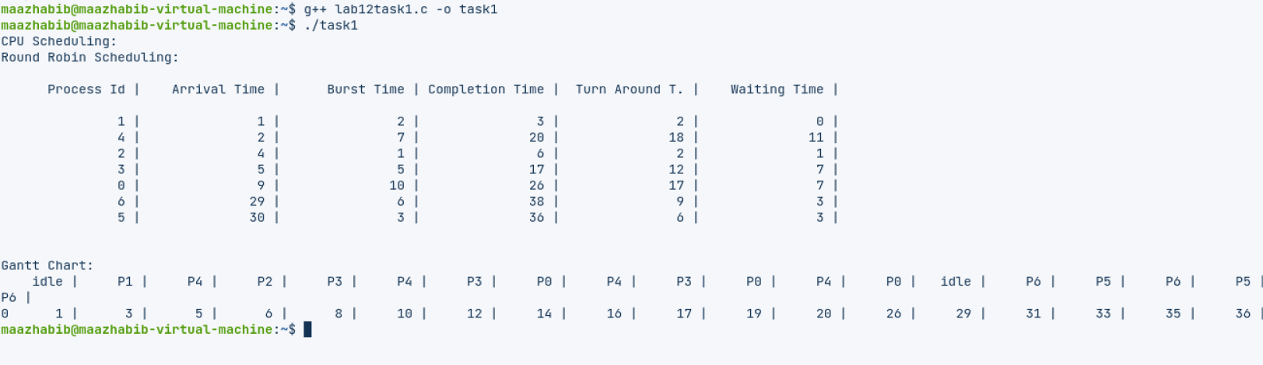

**Lab12-Task2:**

**Code:**

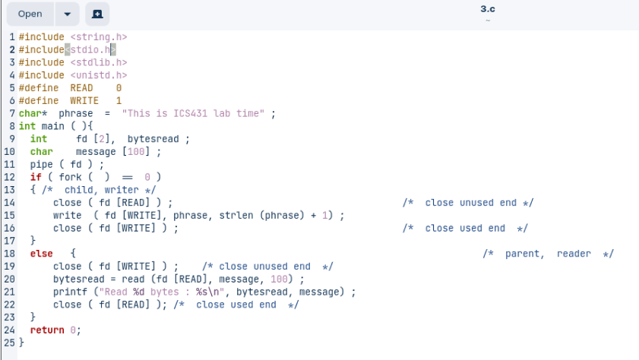

**OutPut:**

